

ASSIGNMENT
Information And Communication Technologies

Topic: Scavenger Hunt And MS Word

Submitted To: Mr. M Moeen Ud Din
Submitted By: Yasoob Haider
Registration No.: 2520236 (BSAVM-1)
Date Of Submission: 6–10-2025
DEPARTMENT OF BUSINESS ADMINISTRATION
AIR UNIVERSITY AEROSPACE & AVIATION CAMPUS KAMRA

Mission 1: Digital Take-off
University Website: | https://www.au.edu.pk/
ICT Services for Students:
1. AU Fee Portal
2. AU Library Portal
2. AU Wi-Fi Network

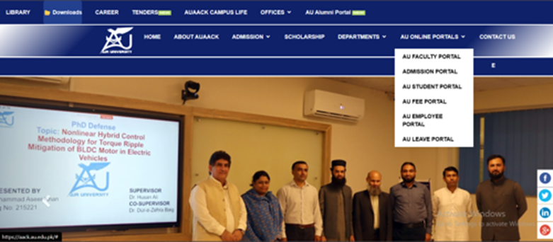

Mission 2: Control Panel Explorer
Processor | Installed RAM | Operating System
Intel Core i7-7820HQ | 16 GB | Windows 11 Pro

Mission 3: Cloud Altitude
File Name | Upload Platform | Upload Date | Status
AvM ICT Yasoob Haider | Google Drive | 07-10-2025 | Uploaded Successfully

Mission 5: Aviation ICT Discovery
How ICT is used in Air Traffic Control:
• ICT enables real-time aircraft tracking through radar and GPS systems.
• It supports communication between pilots and ATC via digital radio links.
• Data management systems enhance safety and reduce human error.

Mission 6: App Radar
App Name | Purpose | Key Feature
FlightRadar24 | Tracks aircraft movements worldwide | Real-time flight tracking and aircraft data
AviationWeather | Provides weather data for pilots | Up-to-date aviation weather forecasts
ForeFlight | Flight planning and navigation | Integrated maps and flight logs for pilots

Mission 7: Data Checkpoint
Aircraft Model | Passenger Capacity | Range (km)
Boeing 777-300ER | 396 | 13,650
Airbus A320neo | 180 | 6,300
ATR 72-600 | 70 | 1,500

Mission 8:
Selfie with Crew

Mission 9: Future Vision
How ICT can make aviation safer or more efficient:
ICT can enhance aviation safety by integrating AI-based monitoring systems that detect anomalies in real time.
Automation of flight operations and digital data sharing improves coordination and reduces delays.

